Year 8 & 9 Reports – A Quick Guide for Parents
This guide is intended to support you to understand the data on the Report and to signpost you to what to look for in your child’s exercise books.
For each subject, your child has been set a GCSE Target by their class teacher. The data they have based this on is in four parts: KS2 Assessment Data (test results and teacher assessment data); MidYIS test results (MidYIS is a baseline assessment completed by your child early in the autumn term of Year 7 and uses four main areas of assessment to generate estimates for subjects: vocabulary, maths, non-verbal and skills); FFT estimates by subject (FFT is a national, non-profit making company providing estimates of future performance to schools) and their own judgement. These targets will be reviewed annually as new National Data becomes available and as your child grows and develops as a learner. As this is a new GCSE system we will continue to monitor and update the targets set to ensure that your child is challenged to achieve their very best throughout their time at school.
Below is guidance from Ofqual about the new grades and their equivalences.
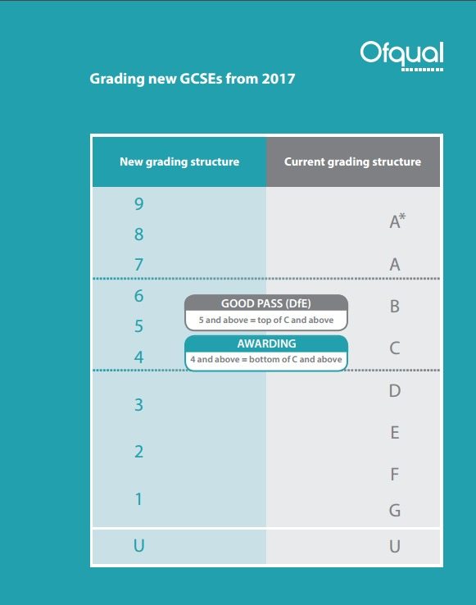
The report also outlines the effort grade and the progress towards their subject target. The descriptions for each number are detailed below:

Effort
1 |  | Excellent Effort
2 |  | Good Effort
3 |  | Minor Concerns
4 |  | Major Concerns
Progress towards target band
1 | Exceptional Progress
2 | Better than Expected Progress
3 | Expected Progress
4 | Not making Expected Progress
5 | Not making Progress

For a fuller picture of your child’s progress you will need to look at their books.
Inside each book you will find a subject progress grid detailing the year 8 or 9 criteria for the GCSE Grades. We are still in the process of developing how to use these effectively in lessons with the students to demonstrate progress.
Subjects may be:
- Highlighting this sheet to show where your child is at currently and using this it is easy to identify what their next steps in learning are.
- The students themselves are developing an awareness of how to use these progress grids to self-assess and set their own next steps in learning.
- Other subject areas are using the GCSE grades in their marking and assessment to be cross referenced with the progress grid to track progress and identify targets.
The books and progress grids have become a very important resource for students, teachers and parents to track progress and understand exactly what the next steps in learning are. If you have any questions or feedback Dr Tinker will be available at parents’ evening during the Spring Term 2018.

