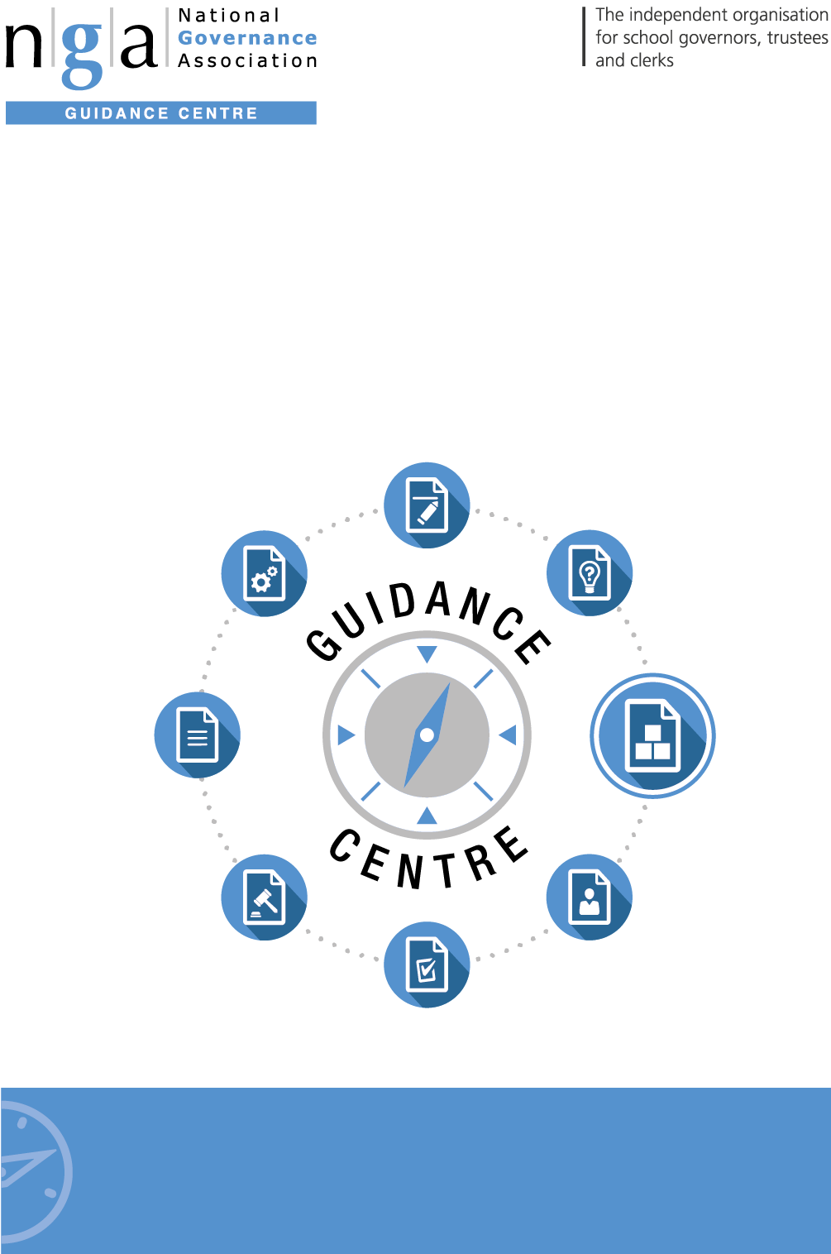

Model Procedures:
Code of Conduct
Legislation, policies and procedures
Need advice?
For advice on any issue, Gold members have access to GOLDline legal advice
9 –5pm weekdays. Find out more T: 0121 237 3782 www.nga.org.uk/goldline

Need advice?
For advice on any issue, GOLD members have access to GOLDline legal advice
9–5pm weekdays. Find out more T: 0121 237 3782 www.nga.org.uk/goldline

National Governance Association
The National Governance Association (NGA) is an independent charity representing and supporting governors, trustees and clerks in maintained schools and academies in England. The NGA’s goal is to improve the well-being of children and young people by increasing the effectiveness of governing boards and promoting high standards. It does this by providing information, guidance, research, advice and training. It also works closely with, and lobbies, UK government and educational bodies, and is the leading campaigning national membership organisation for school governors and trustees.

The NGA online Guidance Centre is the information hub for governors. It supports you in your role as a governor, giving you access to up to date guidance and advice covering all aspects of school governance, including finance; staffing; Ofsted; curriculum; special educational needs; legislation and school improvement.

Practical governance resources include sample documents; templates; checklists; information summaries; insights; case studies and much more.
To join NGA and receive regular updates, contact:
T: 0121 237 3780 | E: membership@nga.org.uk | www.nga.org.uk

Code of Conduct for School Governing Boards

2018 Version

This code sets out the expectations on and commitment required from school governors, trustees and academy committee members in order for the governing board to properly carry out its work within the school/s and the community. It can be amended to include specific reference to the ethos of the particular school. Unless otherwise stated, ‘school’ includes academies, and it applies to all levels of school governance.

This code can also be tailored to reflect your specific governing board and school structure, whether that is as a maintained school or academy, either as a single school or group of schools. Where multiple options are given, i.e. senior executive leader/headteacher and governor/trustee/academy committee member, please amend to leave the option relevant to your governing board.

Once approved by the governing board, the Code will apply to all governors/trustees/academy committee members.

This Code should be read in conjunction with the relevant law and for academies, their articles of association and agreed scheme of delegation. It should be adapted as appropriate depending on the governance setting and level of delegation.

The governing board has the following strategic functions:

Establishing the strategic direction, by:
- Setting and ensuring clarity of vision, values, and objectives for the school(s)/trust
- Agreeing the school improvement strategy with priorities and targets
- Meeting statutory duties

Ensuring accountability, by:
- Appointing the lead executive/headteacher (where delegated)
- Monitoring the educational performance of the school/s and progress towards agreed targets
- Performance managing the lead executive/headteacher (where delegated)
- Engaging with stakeholders
- Contributing to school self-evaluation

Overseeing financial performance, by:
- Setting the budget
- Monitoring spending against the budget
- Ensuring money is well spent and value for money is obtained
- Ensuring risks to the organisation are managed

As individuals on the board we agree to the following:

Role & Responsibilities
- We understand the purpose of the board and the role of the executive leaders.
- We accept that we have no legal authority to act individually, except when the board has given us delegated authority to do so, and therefore we will only speak on behalf of the governing board when we have been specifically authorised to do so.
- We accept collective responsibility for all decisions made by the board or its delegated agents. This means that we will not speak against majority decisions outside the governing board meeting.
- We have a duty to act fairly and without prejudice, and in so far as we have responsibility for staff, we will fulfil all that is expected of a good employer.
- We will encourage open governance and will act appropriately.
- We will consider carefully how our decisions may affect the community and other schools.
- We will always be mindful of our responsibility to maintain and develop the ethos and reputation of our school/group of schools. Our actions within the school and the local community will reflect this.
- In making or responding to criticism or complaints we will follow the procedures established by the governing board.
- We will actively support and challenge the executive leaders
- We will accept and respect the difference in roles between the board and staff, ensuring that we work collectively for the benefit of the organisation;
- We will respect the role of the executive leaders and their responsibility for the day to day management of the organisation and avoid any actions that might undermine such arrangements;
- We agree to adhere to the school’s rules and polices and the procedures of the governing board as set out by the relevant governing documents and law
- When formally speaking or writing in our governing role we will ensure our comments reflect current organisational policy even if they might be different to our personal views;
- when communicating in our private capacity (including on social media) we will be mindful of and strive to uphold the reputation of the organisation

Commitment
- We acknowledge that accepting office as a governor/trustee/academy committee member involves the commitment of significant amounts of time and energy.
- We will each involve ourselves actively in the work of the governing board, and accept our fair share of responsibilities, including service on committees or working groups.
- We will make full efforts to attend all meetings and where we cannot attend explain in advance why we are unable to.
- We will get to know the school/s well and respond to opportunities to involve ourselves in school activities.
- We will visit the school/s, with all visits arranged in advance with the senior executive leader/headteacher and undertaken within the framework established by the governing board.
- When visiting the school in a personal capacity (i.e. as a parent or carer), we will maintain our underlying responsibility as a governor/trustee/academy committee member.
- We will consider seriously our individual and collective needs for induction, training and development, and will undertake relevant training.
- We accept that in the interests of open governance, our full names, date of appointment, terms of office, roles on the governing board, attendance records, relevant business and pecuniary interests, category of governor and the body responsible for appointing us will be published on the school’s website.
- In the interests of transparency we accept that information relating to governors/trustees/academy committee members will be collected and logged on the DfE’s national database of governors (Get information about schools).

Relationships
- We will strive to work as a team in which constructive working relationships are actively promoted.
- We will express views openly, courteously and respectfully in all our communications with other governors/trustees/academy committee members, the clerk to the governing board and school staff both in and outside of meetings.
- We will support the chair in their role of ensuring appropriate conduct both at meetings and at all times.
- We are prepared to answer queries from other board members in relation to delegated functions and take into account any concerns expressed, and we will acknowledge the time, effort and skills that have been committed to the delegated function by those involved.
- We will seek to develop effective working relationships with the executive leaders, staff and parents, the trust, the local authority and other relevant agencies and the community.

Confidentiality
- We will observe complete confidentiality when matters are deemed confidential or where they concern specific members of staff or pupils, both inside or outside school.
- We will exercise the greatest prudence at all times when discussions regarding school/trust business arise outside a governing board meeting.
- We will not reveal the details of any governing board vote.
- We will ensure all confidential papers are held and disposed of appropriately.

Conflicts of interest
- We will record any pecuniary or other business interest (including those related to people we are connected with) that we have in connection with the governing board’s business in the Register of Business Interests, and if any such conflicted matter arises in a meeting we will offer to leave the meeting for the appropriate length of time.
- We accept that the Register of Business Interests will be published on the school/trust’s website.
- We will also declare any conflict of loyalty at the start of any meeting should the situation arise.
- We will act in the best interests of the school as a whole and not as a representative of any group, even if elected to the governing board.

Ceasing to be a governor/trustee/academy committee member
- We understand that the requirements relating to confidentiality will continue to apply after a governor/trustee/academy committee member leaves office

Breach of this code of conduct
- If we believe this code has been breached, we will raise this issue with the chair and the chair will investigate; the governing board will only use suspension/removal as a last resort after seeking to resolve any difficulties or disputes in more constructive ways.
- Should it be the chair that we believe has breached this code, another governing board member, such as the vice chair will investigate.

NGA 2018 CODE OF CONDUCT – page 7

The seven principles of public life
(Originally published by the Nolan Committee: The Committee on Standards in Public Life was established by the then Prime Minister in October 1994, under the Chairmanship of Lord Nolan, to consider standards of conduct in various areas of public life, and to make recommendations).

Selflessness - Holders of public office should act solely in terms of the public interest.

Integrity - Holders of public office must avoid placing themselves under any obligation to people or organisations that might try inappropriately to influence them in their work. They should not act or take decisions in order to gain financial or other material benefits for themselves, their family, or their friends. They must declare and resolve any interests and relationships.

Objectivity - Holders of public office must act and take decisions impartially, fairly and on merit, using the best evidence and without discrimination or bias.

Accountability - Holders of public office are accountable to the public for their decisions and actions and must submit themselves to the scrutiny necessary to ensure this.

Openness - Holders of public office should act and take decisions in an open and transparent manner. Information should not be withheld from the public unless there are clear and lawful reasons for so doing.

Honesty – Holders of public office should be truthful

Leadership – Holders of public office should exhibit these principles in their own behaviour. They should actively promote and robustly support the principles and be willing to challenge poor behaviour wherever it occurs.

Adopted by the governing board of The Corbet School on 21/10/19

I agree to abide by the adopted NGA code of conduct:-

Signed: ______________________________________ Date:__________________

