Full-time teacher of
KS3& KS4 French/Spanish
MAY 2026
Application Information Pack



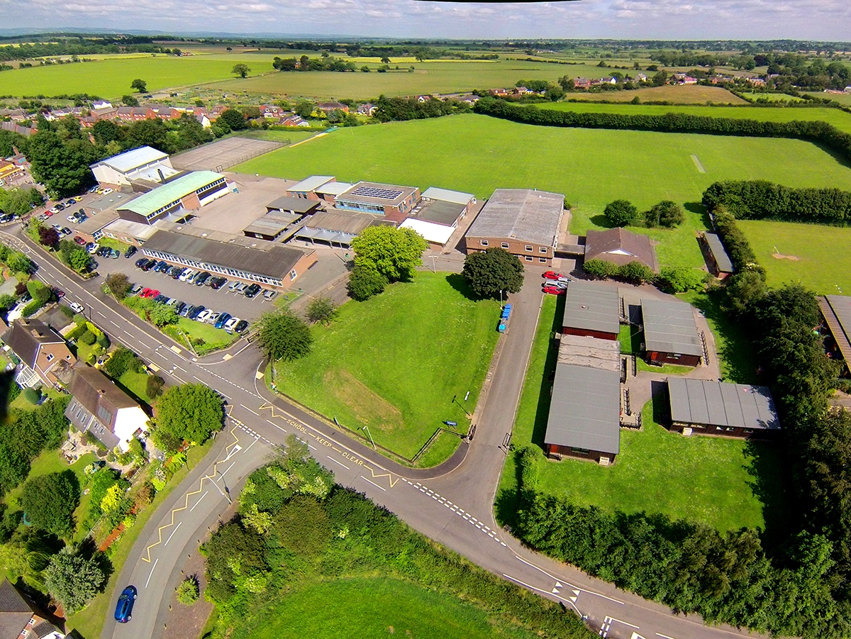



February 2026

Dear Applicant,

POST: Teacher of French and/or Spanish
Full-time (1.0FTE) Part-time may be considered
Permanent
Reporting to: Head of MFL

This post is an excellent opportunity for those wishing to work in a supportive and progressive school. The Corbet School is committed to the development of its staff members in order to maximise benefit to the school as well as support individual career opportunities.

To aid your application, please read the overview containing details of the job description, person specification and the role of the class teacher.

Please note the deadline for applications is 12 noon Wednesday, 25th February 2026

We hope this information is useful in allowing candidates to gain a wider understanding of the school and the post.

We look forward to receiving an application from you. We hope that you find the enclosed information helpful and are excited by the opportunities of this post.

Best wishes,

Dr Jane Tinker
Headteacher
The Corbet School

The Corbet School

The Post
The Corbet School requires from 1st May 2026 a well-qualified graduate to join our MFL Faculty.

The official start date of the Summer Term is the 1st May, the deadline for resignation to take up an appointment on the 1st May is 28th February.

We are seeking to appoint an enthusiastic qualified teacher of KS3and KS4 French and/or Spanish. This is an excellent opportunity to work in a supportive, progressive and outstanding MFL Faculty.

Over recent years the faculty has maintained an excellent record of French and Spanish results at GCSE level, and therefore the post is most suitable for an experienced teacher.

The successful candidate should be able to teach KS3 and KS4 French and/or Spanish.

The successful candidate may be required to become a Form Tutor and be actively involved in the teaching of Personal, Social, Health and Economic Education.

A person specification and job description follow in this pack.

Application
Application should be received by the Assistant Business Manager, midday Wednesday, 25th February 2026.

The Interview
Interviews are scheduled to take place on: Friday, 27th February 2026

OUR SCHOOL

The Corbet School is an, 11-16, Converter Academy. It is a mixed comprehensive school situated in a pleasant, rural position eight miles from Shrewsbury and eleven miles from Oswestry. The Welsh border is about twelve miles to the west and some fifty miles away is the attractive Mid-Wales coastline. Housing in Shropshire is cheaper than in some other areas of the country.

Originally opened in 1957, The Corbet School was re-organised as a comprehensive school in 1977. It serves a circular attendance area of some eight miles radius and therefore a large proportion of the 691 pupils travel by the school bus and take school meals. The school enjoys a good reputation in the county and a number of children attend from outside the attendance area. The school day commences at 8.45 am and ends at 3.20 pm, and is organised into a 5 period day (one hour per period). The day is split two: two: one with a break at 11.10 am and lunchtime starting at 1.30 pm.

The school chose to adopt Foundation Status as from September 1999, and from September 2011 applied for and adopted Academy Status.

The Corbet Parent Association is very supportive and fosters both parental contact and involvement. It has proved to be extremely helpful to the school in raising considerable, financial sums.

OFSTED REPORT – MARCH 2022

The Corbet School provides a happy and kind environment where pupils thrive. Pupils say that staff are friendly and approachable. They feel safe and trust staff to help them if they have a problem. Behaviour is good and bullying is rare. If it does occur, staff deal with it well.

Leaders, want the best for every pupil. They have designed an ambitious curriculum which is broad and balanced. Teachers deliver the curriculum well. Lessons are thoughtfully planned. Pupils say that work is challenging, and teachers help them to do their best. As a result, pupils are achieving well.

The school offers pupils a wide range of extra-curricular opportunities. Examples include sports, art, astronomy, chess and drama clubs. Attendance at these activities is flourishing, with many pupils keen to get involved. For example, large numbers of pupils were seen participating in auditions for the current school production, ‘Into the Woods’.

The vast majority of parents and carers would recommend the school. They praise the quality of teaching and pastoral support. Many comment that their children were well supported through the COVID-19 pandemic. One parent summed up the views of many by saying ‘I could not be happier, and neither could my child.’

CURRICULUM

We have 32 full-time and 16 part-time teachers who deliver a wide curriculum in academic, practical and leisure pursuits. Although broad-based, the curriculum remains balanced with setting in core subjects. In the Upper School, pupils experience a core curriculum, including for many, languages. In 2025 we achieved

- Attainment 8: 47.24
- Standard Pass (9-4) in English (Literature or Language) 75.3%
- Strong Pass (9-5) in English (Literature or Language) 58%
- Standard Pass (9-4) in Maths 72%
- Strong Pass (9-5) in Maths 54.7%
- Standard Pass (9-4) in English and Maths 63.3%
- Strong Pass (9-5) in English and Maths 44.7%
- Students achieving a standard pass (9-4) in two sciences (Combined or Separate) 70.9%
- Students achieving 5+ standard passes (9-4) Inc. English & Maths 60.7%
- Students achieving at least one qualification (9-1) 100%

Pupils transfer for further education to either Shrewsbury Colleges Group, the Walford and North Shropshire College and some into other local schools who are Sixth Form providers as well as some private sector schools.

Children's pastoral needs are recognised by organising the pupils into small, tutor groups in each year on a horizontally grouped basis, with some continuance of tutors between KS3 and KS4. Each year group is assigned a Head of Year, and is overseen by an Assistant Headteacher.

We have a house system which creates healthy competition and the opportunity to develop pupil interests and aptitudes both within and outside the formal curriculum. The five houses are directed by Heads of House.

Extra-curricular activities are well established. Some take place at lunchtime due to the high proportion of pupils who use school buses before and after school (approx. 80%). Others, including inter-school sports matches and visits to the theatre, etc., take place after school and parents arrange for the collection of their children. Each year, various school parties enjoy visits further afield in Britain and on the continent.

STAFFING

The departmental structure within the school is as follows:

English, Mathematics & Computing, Science, Art & Design & Technology, Humanities, Modern Languages, Performing Arts, Physical Education, PSHEE, and Learning Support.

The Head believes in distributed leadership model, with a wide measure of responsibility given to senior and middle managers. Teachers have considerable freedom and leadership is encouraged at all levels of school. The school has good systems to monitor performance and ensure accountability.

The Leadership Team consists of the Head, Deputy Head, three Assistant Heads and the Director of Business, Finance & Operations. Various staff meetings are held which make recommendations to the Head on all aspects of school policy and give the staff opportunities to participate in decision-making. Working parties address themselves to specific issues. We feel that this open style of management ensures that staff accept collective responsibility for the implementation of all aspects of school policy and feel committed to shaping the school's future.

BUILDINGS AND FACILTIES

In addition to normal classroom provision, there is specialist accommodation for:

Art, Food Technology, Textiles, Technology resistant materials, Graphics Studio, electronics, five Science Laboratories, Music, Humanities, Library, assembly/dining hall, 3 Computer Rooms, Gymnasium, Sports Hall, Modern Foreign Languages and Drama.

The school is always seeking to improve, refurbish and extend its buildings. The most recent refurbishments include roofing, heating and electrical works, and classroom refurbishments to Science Laboratories and Music.

The school has also up graded the IT Network capability, and communication systems, and introduced High-Definition Interactive Screens into all appropriate classrooms.

All teachers are issued with a laptop that enables them to access the network within school, and remotely via wi-fi.

TEACHER OF FRENCH / SPANISH
Role: Full-time Teacher of French and/or Spanish

Pay Range: Main Pay Scale / Upper Pay Scale

Line Manager: Head of MFL Faculty

The successful candidate will:

- have qualified teacher status
- experience of teaching French and/or Spanish at Secondary level
- a commitment to raising standards and to gaining the best outcomes for all students.

We can offer:

- a calm and supportive school community
- a strong leadership team and a dedicated team of staff
- a committed and supportive Governing Board
- a firm commitment to your ongoing professional development.

APPOINTMENT OF TEACHER OF FRENCH / SPANISH

The Corbet School requires from May 2026 a well-qualified graduate to join our MFL Faculty. The successful candidate should be able to teach KS3 & KS4 French and/or Spanish. The successful candidate will have a real desire to build on the strengths of the faculty. Enthusiasm, ambition and vision are essential requirements. You will need to be committed to curriculum development and ensuring high quality teaching and learning across the faculty. This is a fantastic opportunity to join a very successful and ambitious school.

The Corbet School is “Very Good” and over-subscribed, rural, 11-16 comprehensive with outstanding pupil behaviour and consistently high results, highlighted by our progress scores.

MODERN FOREIGN LANGUAGES

The MFL Faculty is a successful and flourishing one, and the subjects are popular with pupils.

The curriculum plan is based on a 25 hour weekly timetable, as follows:

AT KS3
Years 7, 8, 9 in mixed ability sets. Pupils receive three hours per week of either French or Spanish

AT KS4
Years 10 pupils receive 3 hours per week of either French or Spanish

Year 11 pupils receive 2 hours per week of either French or Spanish

The department has consistently had good results in examinations.

The most recent results are shown below:

GCSE Examination Results 2025

 | GCSE French – ACTUAL GRADES
Numbers Entered | 9 | 8 | 7 | 6 | 5 | 4 | 3 | 2 | 1 | U
67 | 1 | 3 | 2 | 2 | 14 | 12 | 22 | 11 | 0 | 0

 | GCSE Spanish – ACTUAL GRADES
Numbers Entered | 9 | 8 | 7 | 6 | 5 | 4 | 3 | 2 | 1 | U
62 | 2 | 1 | 1 | 2 | 12 | 9 | 11 | 12 | 12 | 0

The teaching staff within the MFL Faculty from next September is expected to be:

Head of MFL Faculty | Part-time (0.6FTE)
Second in MFL | Full-Time
Teacher of MFL & Head of Year | Full-time
Teacher of MFL | Full-time (This post)
Teacher of MFL | Part-time (0.12FTE)
Teacher of KS4 Spanish | Part-time (0.06FTE)

The department allows pupils the chance to work outside their set taught lessons, providing the opportunity to work at lunch time and in after school clubs at KS3 and GCSE level.

The post will be most suitable for an experienced teacher on the Main Pay Scale / Upper Pay Scale.

LIFE SKILLS

In Year 7/8 and Year 10/11 life skills is taught as a lesson a week, within Year 9 this is delivered via drop down days. This follows the PSHEE program and includes the statutory requirement of RSE. Any successful candidate would be expected to be actively involved in this program.

FORM TUTOR

The successful applicant may be required to undertake the role of Form Tutor.
JOB DESCRIPTION: CLASS TEACHER

This appointment is subject to the current conditions of employment of teachers contained in the School Teachers’ Pay and Conditions Document, Qualified Teacher Status standards, other current educational legislation and the school’s articles of government.

This job description may be amended at any time following discussion between the Headteacher and member of staff, and will be reviewed annually.
DUTIES AND RESPONSIBILITIES: PLANNING

Plan teaching to achieve progression in pupils’ learning through:

- identifying clear teaching and learning objectives and specifying how they will be taught and assessed
- setting tasks, including homework, which challenge pupils and ensure a high level of interest
- setting appropriate and demanding expectations for pupils’ learning, motivation and presentation of work
- setting clear targets building on prior attainment
- identifying the needs of individuals and groups within the class, taking note of individual education plans and the requirements of the Code of Practice
- making effective use of assessment information when planning lessons
- planning opportunities to contribute to pupils’ literacy and numeracy, and to their personal, spiritual, moral, social and cultural development
- the use of Teaching Assistant time as appropriate.
DUTIES AND RESPONSIBILITIES: TEACHING & CLASS MANAGEMENT

- establish and maintain a safe environment and purposeful working atmosphere which supports learning and in which pupils feel secure and confident
- set high expectations for pupils’ behaviour, establishing and maintaining a good standard of discipline through well-focused teaching and through positive and productive relationships
- provide clear structures for lessons maintaining pace, motivation and challenge
- use a variety of teaching methods to:

(i) structure information well, including outlining content and aims and summarising key points as the lesson progresses
(ii) instruct, demonstrate and give accurate, well paced explanations using appropriate vocabulary
(iii) use effective questioning, listen carefully to pupils, give attention to errors and misconceptions

- select appropriate learning resources and develop study skills through library, ICT and other sources
- ensure pupils acquire and consolidate knowledge, skills and understanding appropriate to the subject taught
- critically evaluate teaching to improve effectiveness.
DUTIES AND RESPONSIBILITIES: MONITORING, ASSESSMENT, RECORDING, REPORTING

- assess how well learning objectives have been achieved and use them to improve specific aspects of teaching
- mark and monitor pupils’ work and set targets for progress
- assess and record pupils’ progress systematically and keep records to check work is understood and completed, monitor strengths and weaknesses, inform planning and recognise the level at which the pupil is achieving
- prepare and present informative reports to parents
OTHER PROFESSIONAL REQUIREMENTS

- have a working knowledge of teachers’ professional duties and legal liabilities
- operate at all times within the stated policies and practices of the school
- establish effective working relationships and set a good example through their presentation and personal and professional conduct
- endeavour to give every child the opportunity to reach their potential and meet high expectations

- contribute to the life of the school through effective participation in meetings and management systems necessary to co-ordinate the management of the school
- take responsibility for their own professional development and duties in relation to school policies and practices
- liaise effectively with parents and governors as necessary
- in addition to carry out other duties as reasonably required by the Headteacher.
GENERAL

- Comply with individual responsibilities, in accordance with the role, for health & safety in the workplace.
- Ensure all duties and services provided are in accordance with the school’s Equal Opportunities policy.
- The members and the trustees are committed to safeguarding and promoting the welfare of children and young people and expects all staff and volunteers to share this commitment.
- Participate in the performance and development review process, taking personal responsibility for identification of learning, development and training opportunities in discussion with line manager.

Whilst every effort has been made to explain the main duties and responsibilities of the post, each individual task needing to be undertaken may not be identified.

The postholder will be expected to comply with any reasonable request from a manger to undertake work of a similar level that is not specified within the job description.

The job description may be amended at any time following discussion with the Line Manager and will be reviewed annually.

PERSON SPECIFICATION

Job Title: Full-time Teacher of French and/or Spanish

Responsible to: Head of MFL Faculty

Category | Essential | Desirable
Qualifications | - Degree  - Qualified Teacher Status
Experience | - Experience of teaching French and/or Spanish at secondary level (successful teaching practice acceptable)  - The ability to teach KS3 & KS4 | - The ability to teach French and/or Spanish
Professional Development | - Willingness and desire to undertake further professional development
Skills & Abilities | - Passion for Modern Foreign Languages education  - Commitment to raising standards and to gaining the best outcomes for all students  - Ability to inspire and motivate students  - Commitment to using ICT to maximise learning  - Commitment to safeguarding  - Commitment to extended learning activities (clubs/enrichment activities, etc)  - Ability to work as a team player  - Ability to work on own initiative  - Strong organisational skills  - Commitment to CPD  - Effective communicator  - Good inter-personal skills

The Corbet School is committed to Safeguarding and promoting the welfare of children, therefore the successful applicant will be required to undertake an enhanced DBS Disclosure.

